AWS Launching an Amazon EC2 in a Non-Default VPC

Adhvitha Sivaganesh| CCNP

Purpose:

In this lesson, I learned how to created an Amazon VPC without the VPC wizard. I created a new VPC and deployed an EC2 instance in the network. I launched a webserver using t-2 micro Amazon EC2 instance and deployed the instance in the VPC that was created.

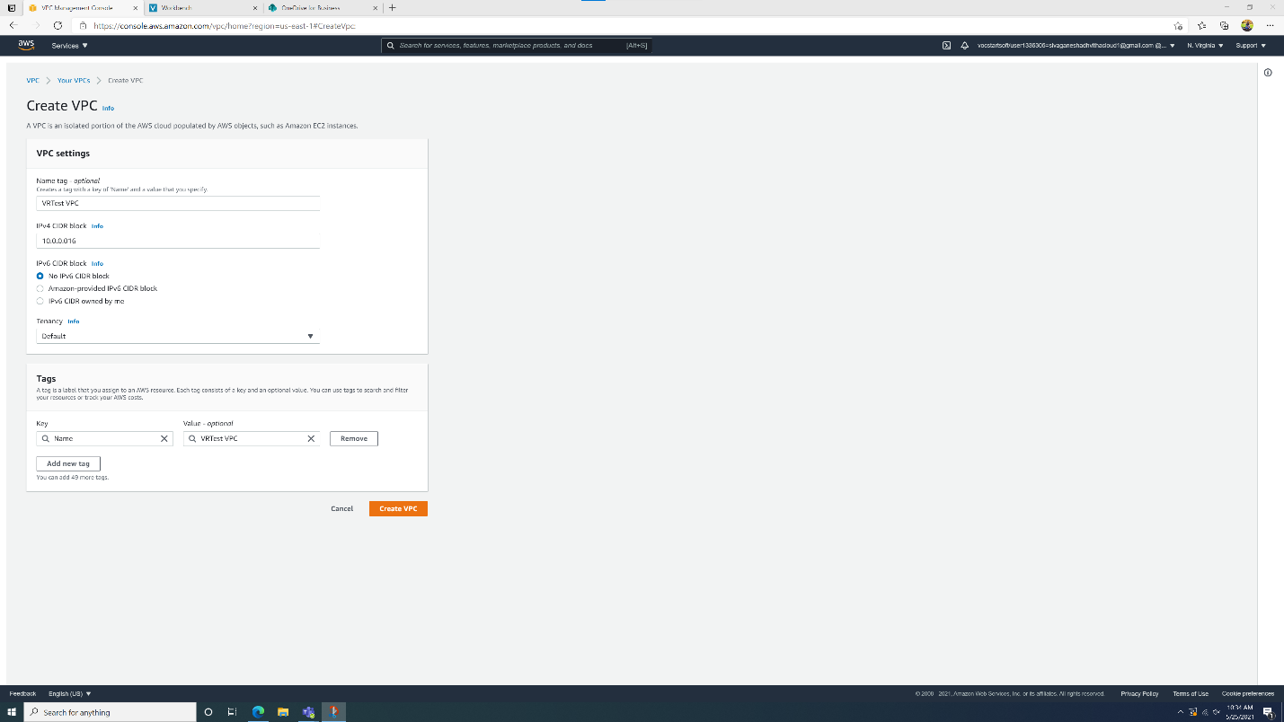

* At the start, I created a VPC with the name tag as “VRTest VPC” and the IPv4 CIDR block as 10.0.0.0/16 with the tenancy set to default

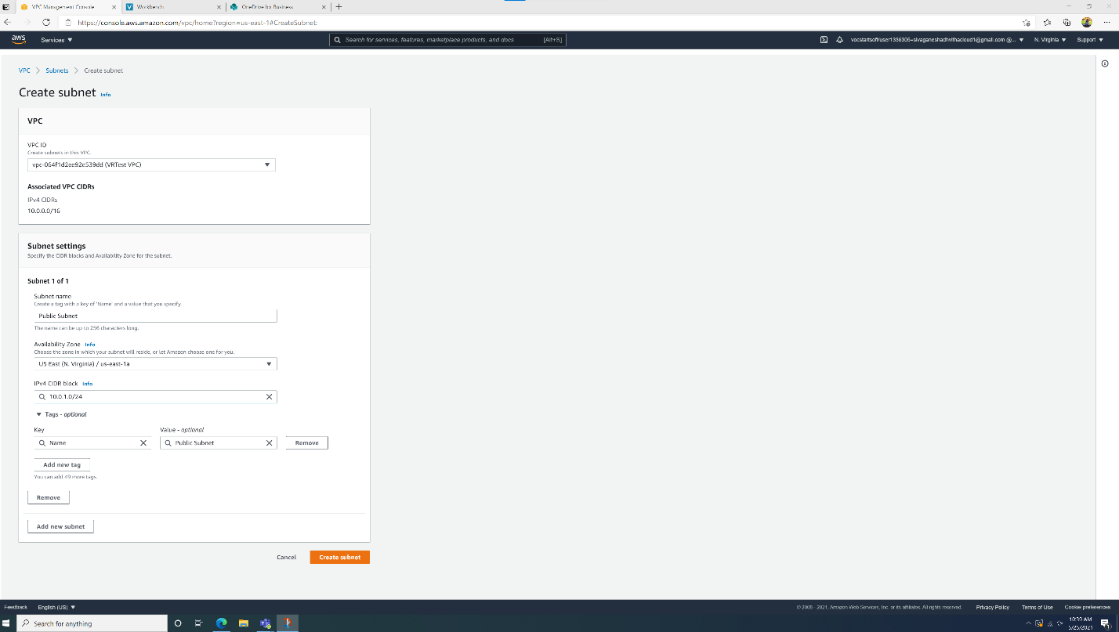

* I went into the subnets tab and created a public and private subnet with specific IPv4 CIDR settings

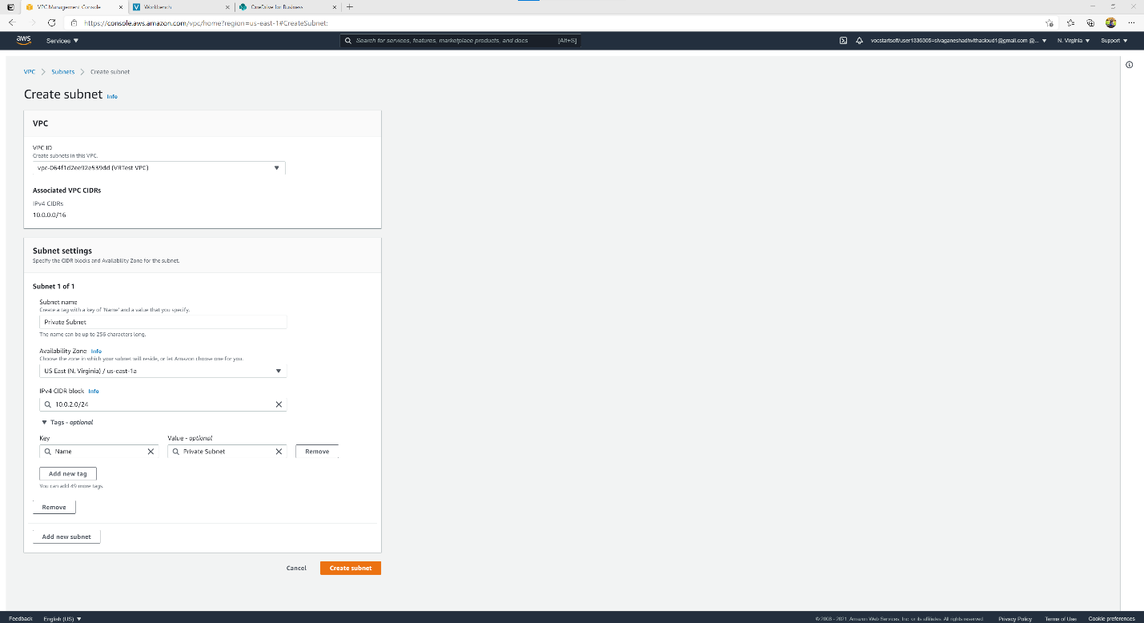

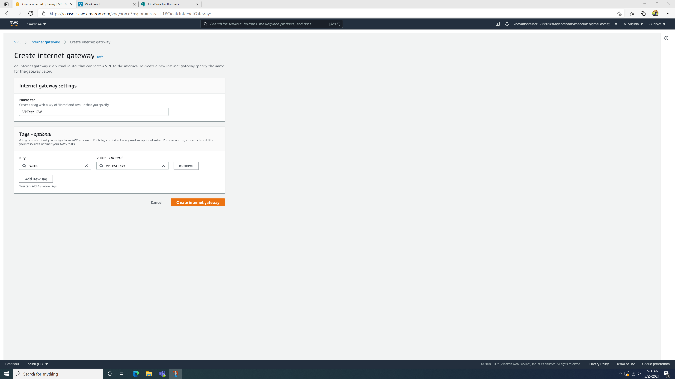

* After that I created a Internet Gateway with the name tag as “VRTest IGW”

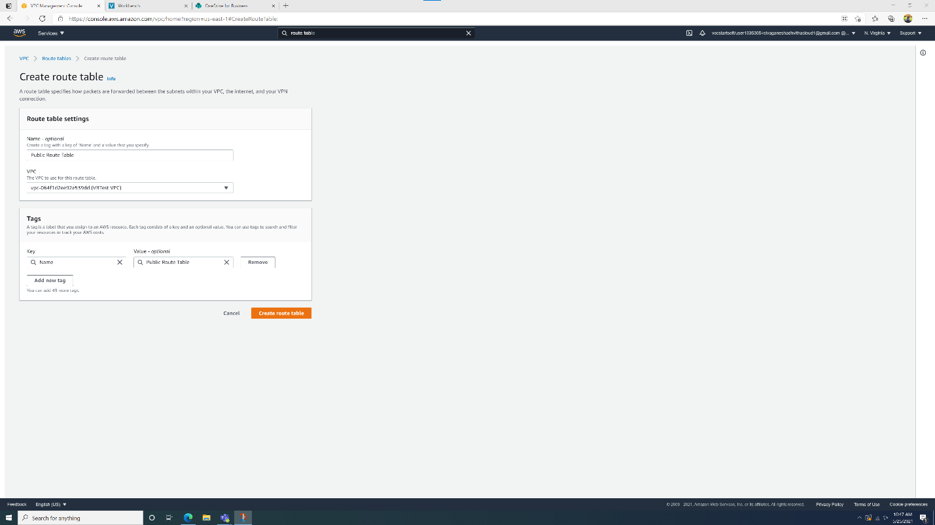

* I then created a route table and added a default route to the internet gateway to the public routing table.

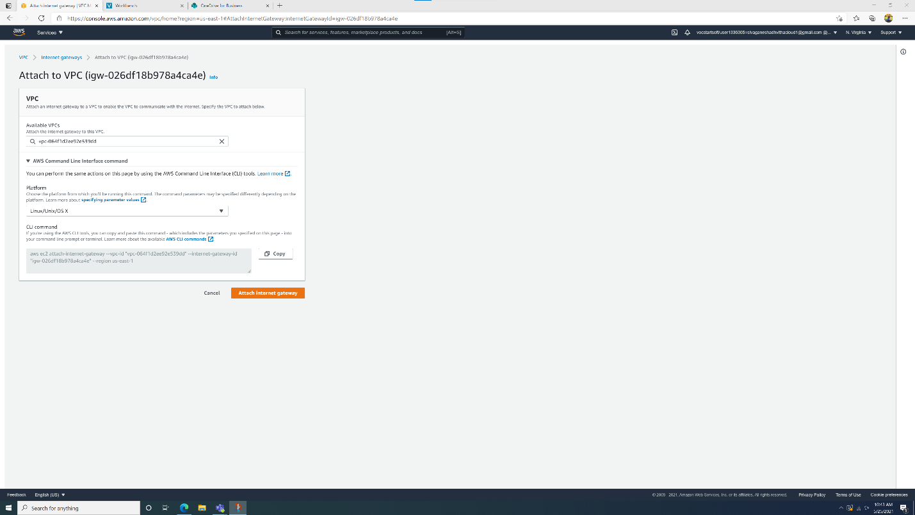

* Next, I selected my internet gateway and attached it to the VPC.

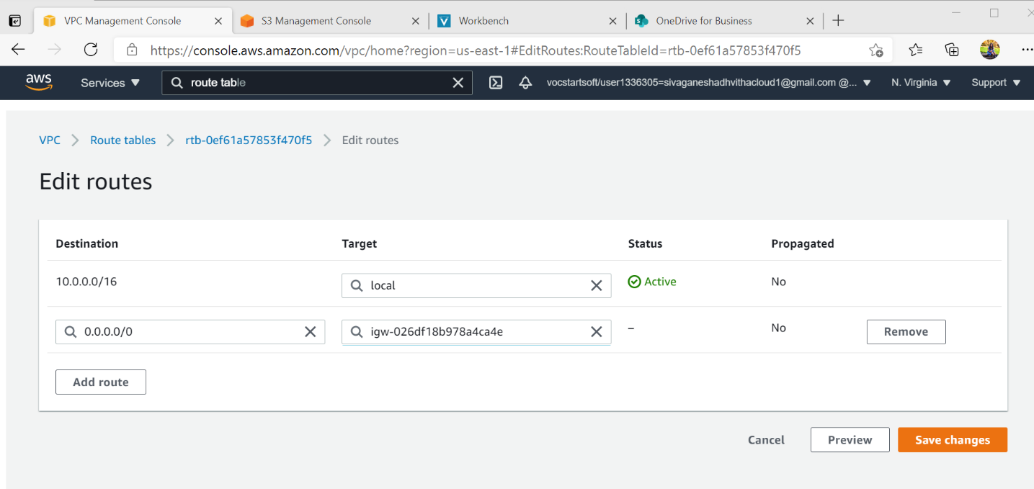

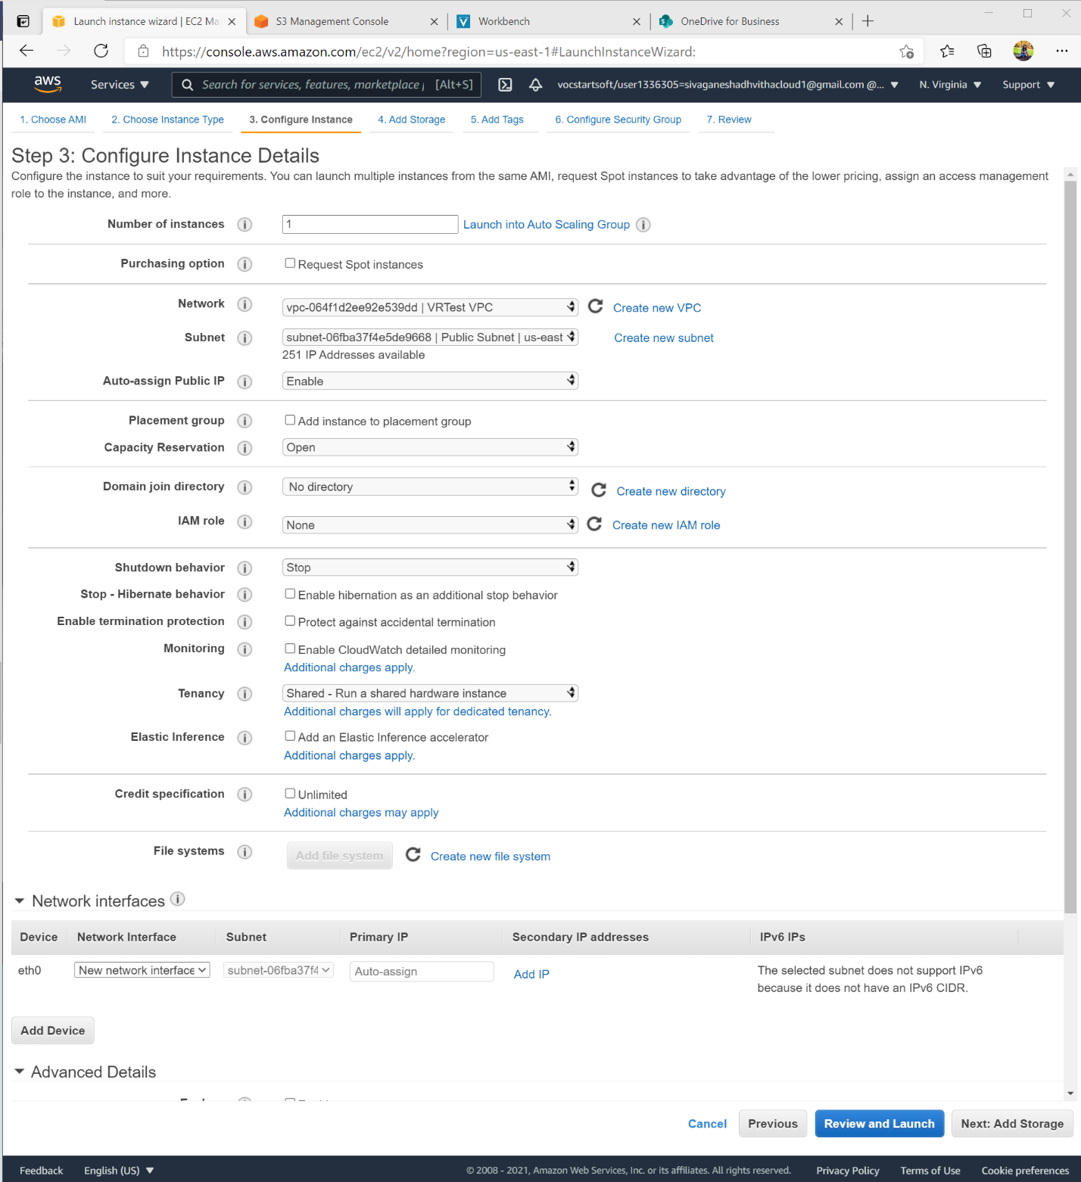

* Afterwards, I configured the instance details and with specific settings and connected it to the VRTest VPC.

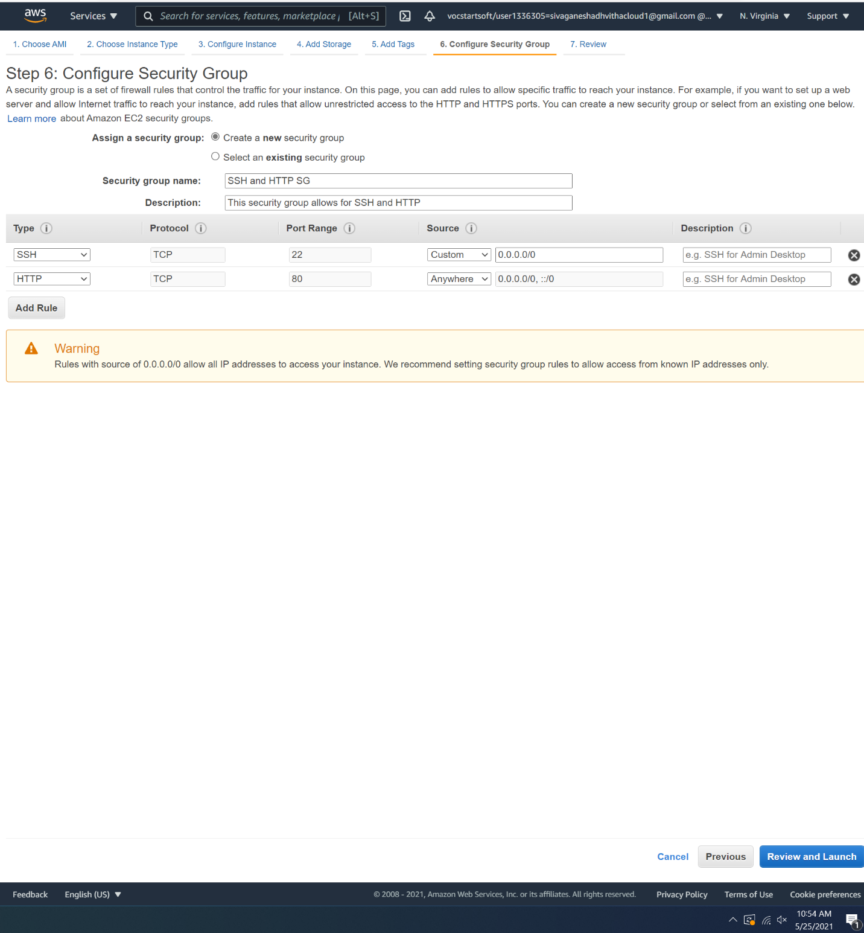

* I went over the storage and tags section and then configured the security group

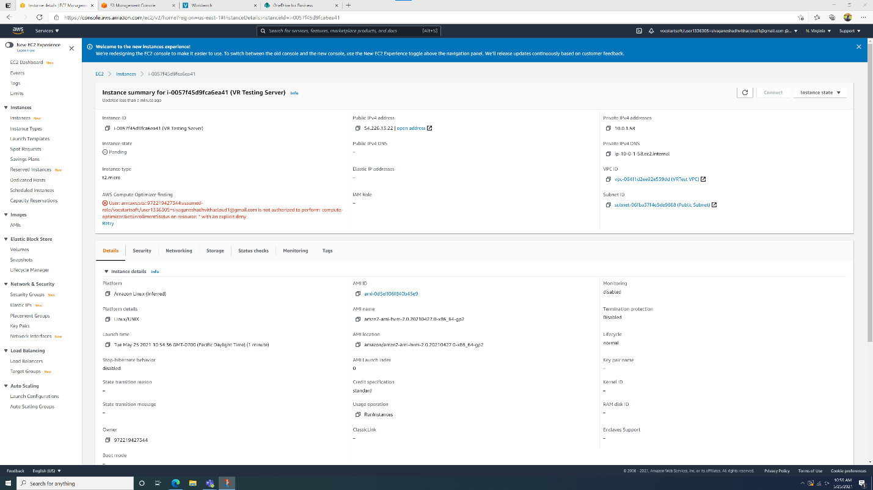

Lastly, I checked everything and launched the instance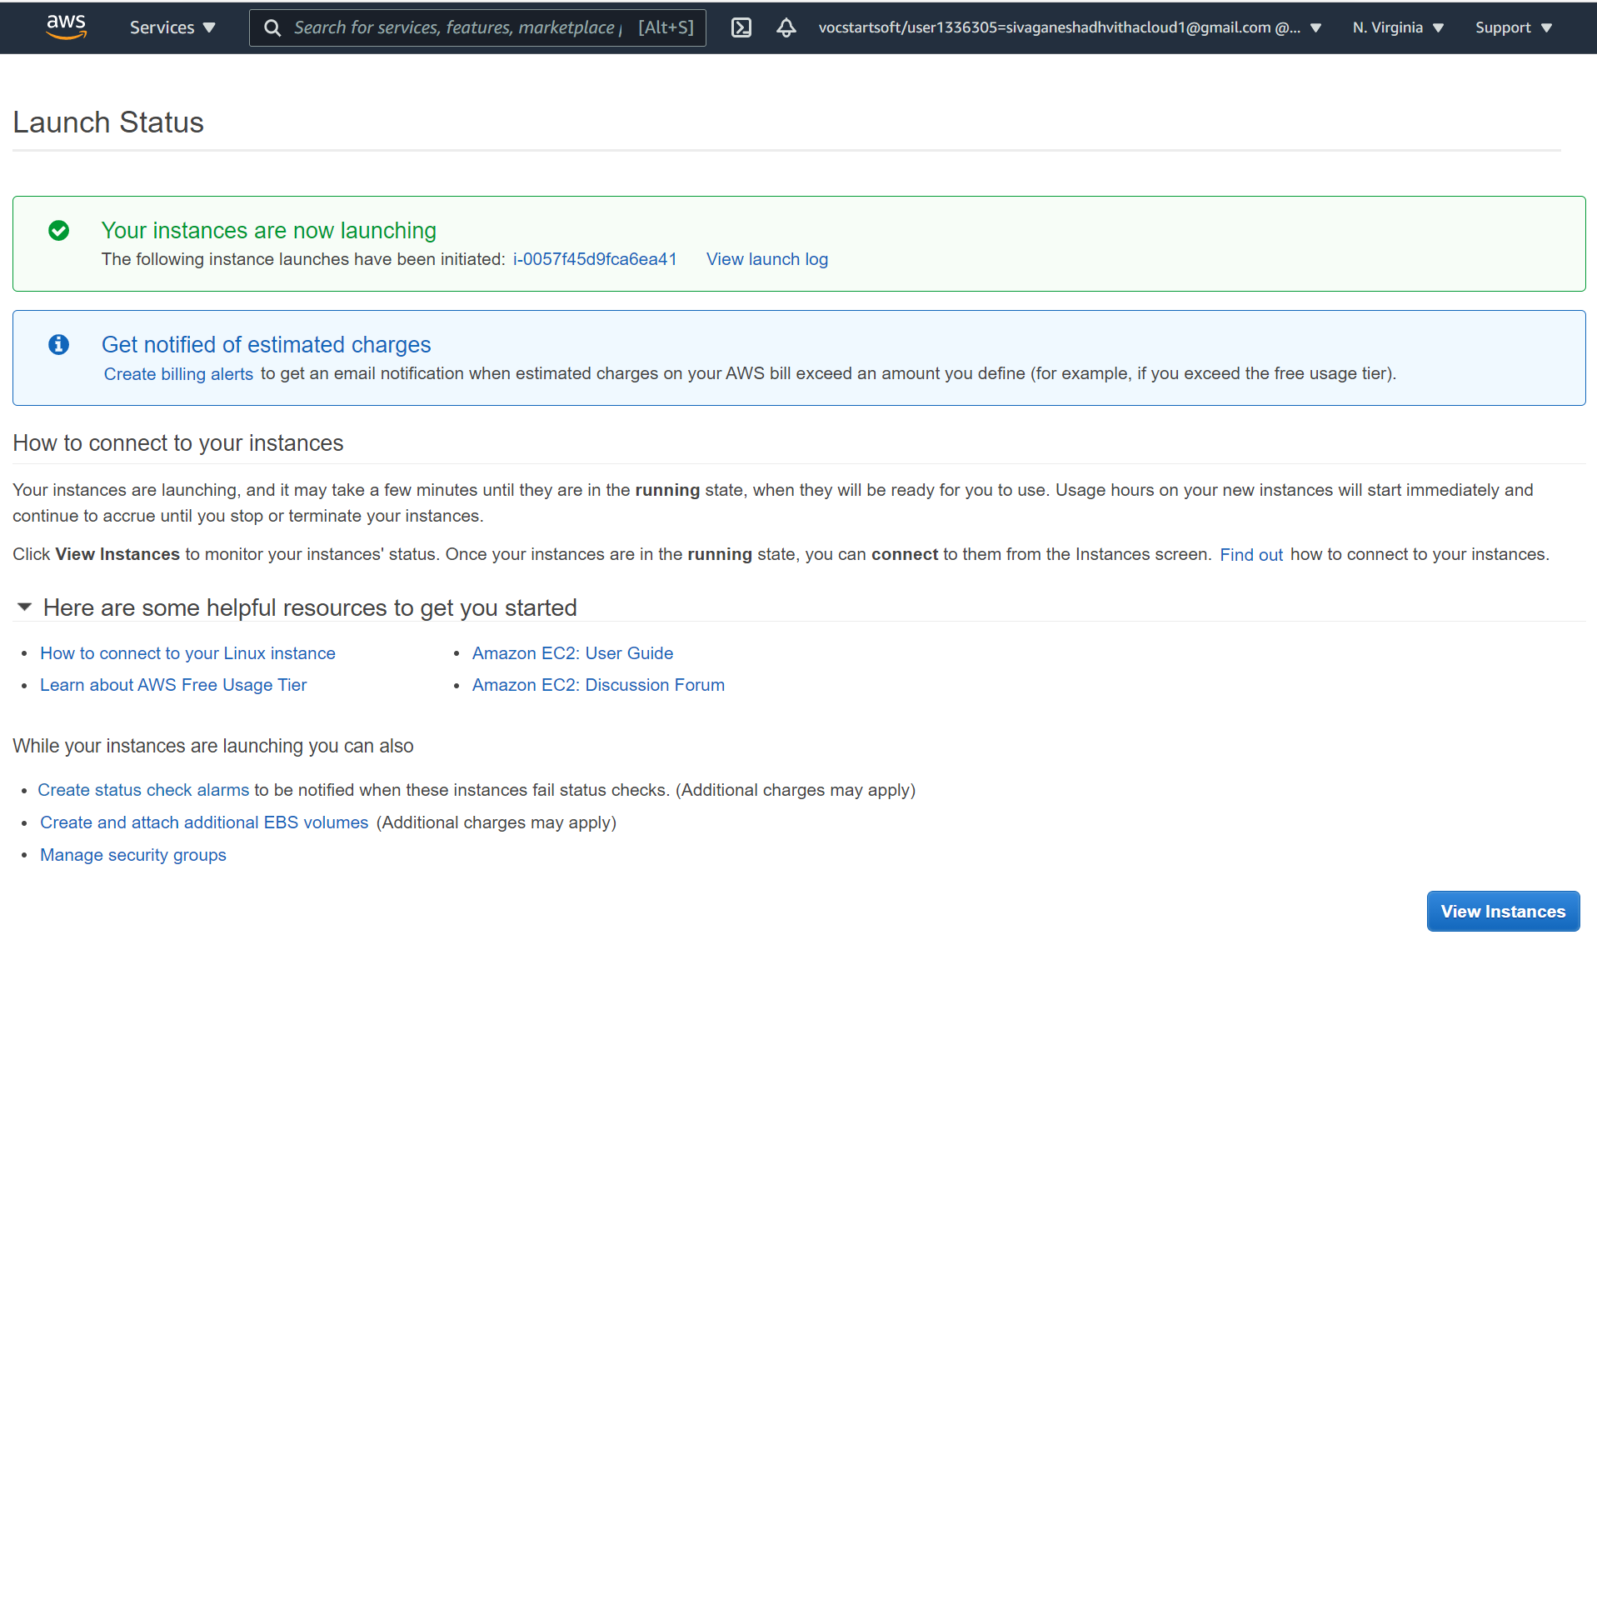

Problems: I created the Amazon VPC and when I tried to access the website it had an error message which mentioned “not authorized to perform” in reference to my AWS account.